Intent/Purpose
The intent of this Local Partnership Agreement (LPA) is to establish a collaboration specific to Riverside Unified School District in conjunction with the Department of Rehabilitation and Inland Regional Center, to support a seamless delivery of services for students (ages 16 to 22 years old) with disabilities. This LPA will promote Competitive Integrated Employment (CIE) and quality of services, which ultimately furthers the preparation and achievement of CIE for youth and adults with intellectual disabilities/developmental disabilities (ID/DD). This LPA allows DOR, IRC and RUSD staff to coordinate Student Services for students through job exploration counseling, workplace readiness training, and work-based learning experiences.

Identification of Core Partners
The core partners include Riverside Unified School District (RUSD) as the Local Education Agency, the Department of Rehabilitation (DOR) and Inland Regional Center (IRC).

The Department of Rehabilitation (DOR) Riverside Office Core Partners. Department of Rehabilitation DOR mission is to work with consumers and stakeholders to provide services and advocacy resulting in employment, independent living, and equality for individuals with disabilities.

DOR Inland Empire District (IED) - Team Managers
Inland Empire District Office: 2010 Iowa Ave., Ste 100, Riverside, CA 92507; (951) 782-6650
Robert Loeun, District Administrator
Christopher Fernandez, Staff Services Manager I
Amanda Spivey, Staff Services Manager I
Craig Rubenstein, Staff Services Manager I Deaf and Hard of Hearing

San Bernardino Branch Office: 464 W. 4th Street. Suite 152.
San Bernardino, CA 9240; (909)383-4401
Yuki Long, Staff Services Manager I Blind Field Services
B. Local Education Agencies (LEA) - Riverside Unified School District
Riverside Unified School District mission is to provide engaging, innovative, and equitable learning experiences for all students.
- Riverside Unified School District Transition Team
  - Jana Stewart - Program Specialist/ WorkAbility Contact
  - Jennifer Walker - Transition Coordinator Mild/Moderate
  - Tedra Trimm - Transition Coordinator Mild/Moderate
  - Laura Williams - Transition Coordinator Life Skills
  - Tracey Cleary - Job Development Specialist
  - Judith Leal - Job Development Specialist
  - Donna Schulte - CTE Job Development Specialist

Riverside Unified School District
Arlington High School
Ramona High School
John W. North High School
Martin Luther King High School
Raincross High School Continuation
Opportunity
Summit View
Lincoln High School Continuation
Project T.E.A.M
Riverside Poly High School
Riverside Virtual School

LEA Contact Info: Riverside Unified School District Pupil Services/ Special Education Department
5700 Arlington Ave Riverside CA, 923507
951-352-1200

Inland Regional Center (IRC) Core Partners:
Vince Toms, Director Community and Resource Development
Felipe Garcia, Director of Children and Transition Units
Elizabeth Tagle, Program Director Riverside Transition
Beth Crane, Employment Specialist

Inland Regional Center:
San Bernardino office: 1365 S. Waterman Ave, San Bernardino, CA 92408; (909) 890-3000
Riverside Office: 1500 Iowa Ave. Suite #100, Riverside, CA 92507; 951-826-3000.

Roles and Responsibilities: Collaboration through Person-Centered Processes
Under the Workforce Innovation Opportunity Act, the five core student services needed for students with disabilities ages 16 to 22.
- Job Exploration Counseling - career exploration opportunities based on student strengths and interests.
- Work - based learning experiences, which may consist of both during school or after school opportunities, experiences outside of the traditional school setting and internships.
- Counseling on opportunities for enrollment in comprehensive transition or postsecondary educational programs.
- Workplace readiness training to develop social (soft skills) and independent living skills.
- Empower Self Advocacy in students in effort to build confidence to living independently and be successful in the workforce.

Person-centered planning (PCP) is a process-oriented approach to empowering individuals with disabilities. PCP has a primary focus on people and their needs by putting them in charge of defining the direction for their lives, not on the systems which may or may not be available to provide services. This ultimately leads to greater inclusion as valued members of both community and society.

Students with Disabilities (SWD): Students (Ages 16 to 22) in secondary school - and who receive services from the following agencies:

Riverside Unified School District in Collaboration CTE and Community Colleges

Riverside Unified School District
Student with disabilities: Develop and refine an Individual Transition Plan (ITP) based on the information. Provide Pre-Employment Transition Skills (Pre-ETS) training and work experience opportunities as appropriate. Assess progress toward CIE readiness per district grading period. Refer to CTE classes as appropriate. Maintain ongoing collaboration with IRC and DOR.

Students with disabilities ages 18 to 22 (Adult Transition Program): Continue services listed above in the adult transition program setting. Facilitate agency linkages and transition services to support agencies. Make referrals to appropriate agencies and or employers as needed.

Riverside Unified School District Career Technical Education (CTE) opportunities
CTE is a program of study that involves a multiyear sequence of courses the integrates core academic knowledge with technical and occupational knowledge to provide students with a pathway to post-secondary education and careers. CTE prepares students to be college and career ready. Students follow a pathway to their specific career goal. Depending on their goal, they can earn a high school diploma, college degree or credits, industry certifications or credential.
Provide CTE class offerings to youth with disabilities. Educate businesses while attending employer events and through targeted information sessions on the employment support programs available through IRC and DOR. Develop and implement class offerings to support the local community rehabilitation programs, i.e. job coaching, targeted instruction, conducting assessment, behavior management, etc. Develop and implement CTE class offerings to enhance workplace skills for student’s i.e. foundational employment skills, self-determination, workplace technology etc. Continue collaborative efforts with RUSD CTE Coordinator on class offerings for high school students.

Department of Rehabilitation (DOR)
DOR assists students with disabilities to obtain and retain employment through job training, education and employment. DOR services may include career assessments and counseling, job search and interview skills, independent living skills, career education training and assistive technology.
Students with disabilities ages 16-21: Provide DOR Student Services to Potentially Eligible, who are defined as students with disabilities, who have not yet applied for or been eligible for the vocational rehabilitation program. This program is intended to help students prepare for workplace success by exploring options, getting ready to work, and creating careers. Students will receive support in the following core areas: workplace readiness, work-based learning, job exploration and counseling, post-secondary counseling, and instruction in self-advocacy. Those students who qualify will transition into the vocational rehabilitation program.

Inland Regional Center IRC
The cornerstone of IRC’s service philosophy is person centered planning. Every person is different. They have unique needs, support systems, goals, and preferences. Our service plans reflect that individuality. IRC Service Coordinators work together with our consumers to create service plans that embody what IRC believes in wholeheartedly: Consumer independence, empowerment, and inclusion.

Students with disabilities ages 16-17: Develop and refine the Individual Program Plan (IPP) based on the information gathered during the PCP process and ongoing collaboration with the LEA. Provide generic services as appropriate to address vocational barriers while in school.

Students will disabilities ages 18 to 22: Attend exit IEP to determine appropriate transition services. Refer students who have a desire to work to DOR and or to community rehabilitation programs for additional training as appropriate.

Referral and Intake Process
The RUCLPA intends to streamline the referral process collectively established between RUSD, DOR, and IRC for students with disabilities.
Best practice is for the LEA to refer all Regional Center clients to IRC for services prior to the student exiting high school. IRC will attend any IEPs including the Exit IEP if available. IRC will refer all students who want to work to DOR for vocational rehabilitation services. The LEA will refer students who want to work and are not Regional Center clients to DOR 6 months prior to the student exiting high school. DOR will attend any IEPs including the Exit IEP if available. Referrals will include agreed upon assessment data.

Local Education Agencies (LEA) - will, with written consent from the parent or student who has reached the age of majority, invite a representative from the Inland Regional Center (IRC) to an IEP meeting prior to exiting high school. IRC will attend any IEPs including the exit IEP if available. IRC will refer all students who want to work to the Department of Rehabilitation (DOR) for determination of vocational rehabilitation services.

The LEA will refer students who want to work and are not IRC clients to the Department of Rehabilitation (DOR) prior to the student exiting high school. DOR will attend any IEPs including the exit IEP if available.

The classroom teacher will obtain written consent from the parent or student who has reached the age of majority to release the following documentation to the IRC and or the DOR representative by the end of the IEP meeting:
- LEA Referral Form to Inland Regional or the Department of Rehabilitation, including a consent to release information.
- IEP – including the Individualized Transition Plan (ITP)
- Psycho-educational report
- Summary of Performance (SOP)
- Transition/ Vocational Assessments
- Portfolio
- Other supporting documents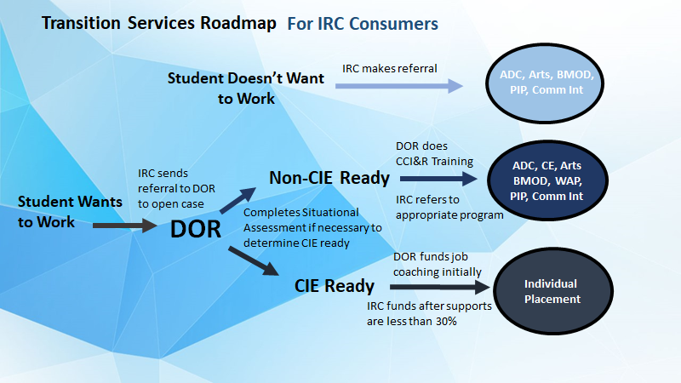

Goals
- The RUCLPA partners will meet quarterly to coordinate education and outreach opportunities for District, staff, parents, and consumers.
- The RUCLPA will increase educational/vocational opportunities for SWDs by incorporating DOR and IRC services.
- Based on the postsecondary completion one year follow-up, the number of SWDs who either entered CIE, post-secondary training or education, or are receiving vocational rehabilitation services in preparation for CIE will increase.
- The number of students on certificate of completion track that participate in paid work experience and/or unpaid community-based vocational education and or activities will increase.
- RUCLPA will implement a standardized referral form which can be utilized by all core partners.

Addendums

Resources (will be deleted when complete):

- Established Local Partnership Agreements: https://www.chhs.ca.gov/home/cie/elementor-11522/
- Community Colleges: Offer support and accommodations through the Disability Programs and Services (DPS) office. Offer enrichment and Career Education (CE) classes. Develop and implement class offerings to support the local community rehabilitation programs, i.e. job coaching, targeted instruction, conducting assessment, behavior management, etc. Develop and implement CE class offerings to enhance workplace skills for students. i.e. foundational employment skills, self-determination, workplace technology etc. Provide support to DOR clients as the employer of record for work experience.

