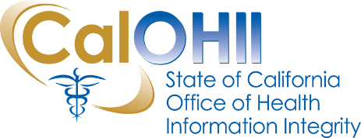
CalOHII Communications
April 2021
In this month’s communication, the California Office of Health Information Integrity (CalOHII) provides updates regarding CalOHII activities and news from the federal Health and Human Services (HHS).
CalOHII Updates
- HHS proposes modifications to HIPAA – CalOHII has drafted a consolidated response for the State and it is currently with California Health and Human Services (CHHS) Agency for final review. HHS extended the deadline for comments to May 6^{thd}.
- Annual Update of the Statewide Health Information Policy Manual (SHIPM) – the annual update of SHIPM is in the final review phase – we are on track for the June publication of the updated SHIPM.
- State Health Information Guidance (SHIG) – The SHIG project is moving forward on various efforts – brief update follows:
  - SHIG 1.0 (Sharing Behavioral Health Information in California) – the current content is being reviewed to ensure it reflects recent federal and state statute and regulation changes.
  - SHIG 2.0 (Reduce Food and Nutrition Insecurity among Vulnerable Californians) – the team is finalizing the content for publication in April. In addition, planning is underway for a webinar on SHIG 2.0 in May.
  - SHIG 3.0 – the CalOHII team continues developing scenarios for foster youth, persons with developmental disabilities, persons with HIV/AIDS, public health, and minors. Planning is underway for Advisory Committee meetings for each topic area.
- HIPAA Compliance – CalOHII continues to work with four (4) departments on their Corrective Action Plan (CAP) action items as well as conducting a Targeted Review with a department.
- State Legislation Review – CalOHII has reviewed almost 400 bills for possible SHIPM impacts – at this time we have over 30 bills we are taking a closer look.
- Incident/Breach – CalOHII continues to review and follow-up with organizations regarding incidents reported to CalCSIRS.
- Technical Assistance – CalOHII continues to provide information to organizations and individuals with questions concerning the privacy protections of health information in California.

HHS News
- Office for Civil Rights (OCR) continues Right of Access Initiative enforcement actions – OCR settled another two investigations in March regarding the Right of Access Initiative. More information about these cases and the other settlements is on the OCR website.
Contact Us…
If you have any questions or comments about the content of this newsletter, contact us at OHIComments@ohi.ca.gov.

Past CalOHII Communications are on the CalOHII Communications - Archive page.

